H.T No
Regulations:
A18

Sreenidhi Institute of Science and Technology
(An Autonomous Institution)
Code No: 7K201 Date: 02-Nov-2021 (AN)

B.Tech I-Year II- Semester External Examination, Oct/Nov-2021 (Supplementary)
ENGINEERING MECHANICS FOR CIVIL ENGINEERING (CIVIL)

Time: 3 Hours Max.Marks:70

Note: a) No additional answer sheets will be provided.
b) All sub-parts of a question must be answered at one place only, otherwise it will not be valued.
c) Missing data can be assumed suitably.

ANSWER ANY 5 OUT OF 8 QUESTIONS. EACH QUESTION CARRIES 14 MARKS.

Bloom's Cognitive Levels of Learning (BCLL)

Remember | L1 | Apply | L3 | Evaluate | L5
Understand | L2 | Analyze | L4 | Create | L6

 |  |  | BCLL | CO(s) | Marks
1. |  | Regular hexagon is subjected to an action of five forces originating from one node point towards other five node points as shown in fig. . Show that the resultant passes through 50N force.  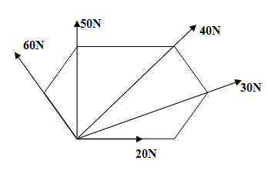 | L3 | CO1 | [14M]
2. |  | A block of weight 36 kg is resting on a rough inclined plane having an inclination of 30˚. A force 12 kg applied at an angle of 10˚ up the plane and the block is just on the point of moving down the plane. Determine the coefficient of friction. | L2 | CO2 | [14M]
3. |  | Find the centroid of plane lamina as shown in fig.  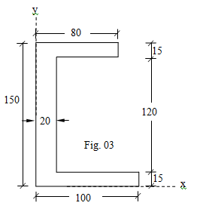 | L4 | CO3 | [14M]
4. |  | A beam AB of span 10 m carries two point loads of 15 kN and 20 kN at 4 m and 6 m from A respectively as shown in fig. . Determine the beam reactions by principle of virtual work.  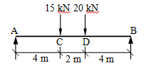 | L3 | CO4 | [14M]
5. |  | An elevator has a downward acceleration of 1m/s². What pressure will be transmitted to the floor of the elevator by a man weighing 500N going in the lift? Find the pressure if the elevator had an upward acceleration of 1m/s². | L4 | CO5 | [14M]
6. |  | A body of mass 50kg moving with a velocity of 6m/sec, collides directly with a stationary body of mass 30kg.if the two bodies become coupled so that they move together after the impact what is the common velocity | L4 | CO6 | [14M]
7. |  | Using the method of joints find the forces in all the members of the truss loaded as shown in figure.  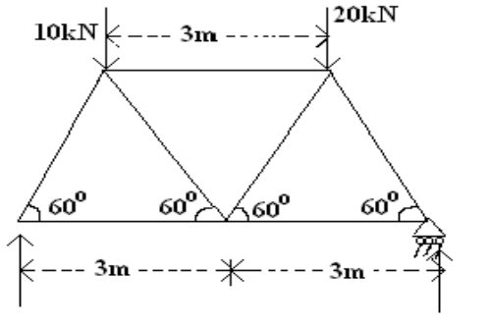 | L2 | CO1 | [14M]
8. |  | Derive the expression for mass moment of inertia of a right circular cylinder by using first principles | L5 | CO4 | [14M]

-- 00 -- 00 –

